LINUX – ASSIGNMENT 1

**Ques. 1. When we create a user, some hidden files are generated in the directory of the**

**same user at that time. How is it done?**

Ans. Hidden files are inside the /etc/skel directory. All files and directories inside the /etc/skel directory are automatically copied over to a new user’s home directory when such user is created by the useradd program.

**Ques. 2. Make subdirectories inside a parent directory by using single mkdir command (refer figure given below).**

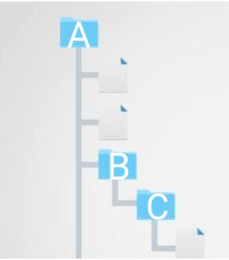

Ans. mkdir -p A/B/C

(-p for parent directory option).

**Ques. 3. tac command v/s cat command**

tac command in Linux is used to concatenate and print files in reverse. This command will write each FILE to standard output, the last line first. When no file is specified then this command will read the standard input.

cat in reverse order is – tac